All PK-6 students are welcome to come meet their teacher, explore their classroom, and find their locker Wednesday, August 13, from 5:00-6:00 pm. This is a come and go event that will end promptly at 6:00 so staff can attend the Welcome Back Meal sponsored by the Baptist Church. This is a great opportunity for your student to bring all of the school supplies, and find their classroom before the first day of school.

**Meet Your Teacher!**

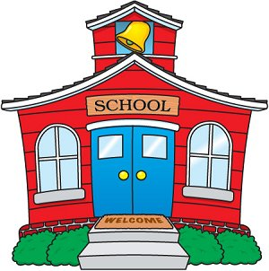

**Wednesday, Aug. 13th**

**5:00-6:00 pm**